DISCOUNT STATISTICS OF CLOSED-END FUNDS
UPDATE FOR THE 1st QUARTER 2016

This article will update the Highland Global study, “Discount Statistics of Closed-end Funds,” (originally published in November 2005 and updated quarterly) for data relating to the first quarter of 2016. The original article with more details regarding discount statistics of closed-end funds is available at www.HighlandGlobal.com. Historic releases of our research can be accessed from our website.

All facts and data as set forth in this report were obtained from sources considered to be reliable. However, Highland Global assumes no liability for the accuracy of the information provided to us by others. Highland Global assumes no responsibility for any liability for damages of any kind resulting from reliance on this report by the reader or any other party. Although «we» have exerted considerable diligence and applied «our» best efforts in constructing this document, immaterial anomalies, if any, may arise. Even so, «we» are confident that «our» overall results would still fall within a materially consistent conclusion. This report is not to be construed, directly or indirectly, as a recommendation to invest, divest or to lend. Highland Global makes no representations or warranties that the result/research set forth in this report will be accepted by any other third party, including any regulatory or government body federal, state, or local.

Google’s Beta Data & Barron’s Closed-End Fund Data

Each quarter, Barron’s Online (www.barrons.com) reports statistics on publicly-traded closed-end funds. The statistics reported include the discount (or premium) of the market price from the fund’s net asset value (NAV), the 52-week average discount or premium, the fund’s objective, and various return measurements, etc. Google (www.google.com/finance) reports various statistics on these funds, including metrics of beta. Highland Global then calculates the discount range, average, median, and standard deviation and reports these figures based on metrics such as the total data population, beta ranges, fund objectives, etc. The following table provides the summary of the analysis of closed-end funds with discounts to NAV during the first quarter 2016.

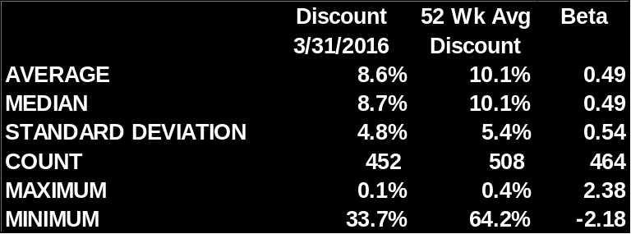
Source: Based on data obtained from www.barrons.com and www.google.com/finance

The following table provides the average and median discounts for the entire population and for those closed-end funds with reported betas for given quarters.

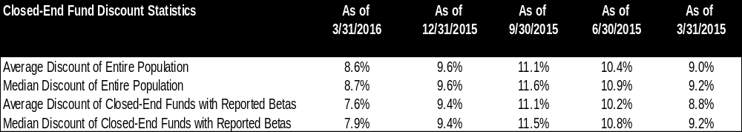
Based on calculations by Highland Global from data obtained from www.barrons.com and www.google.com/finance

The following table provides average and median discounts for the entire population and for those closed-end funds with reported betas for the fifty-two week periods.

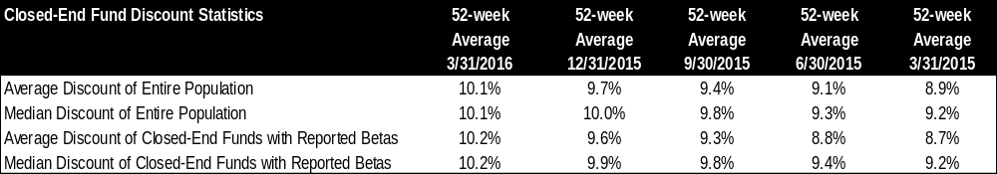
Based on calculations by Highland Global from data obtained from www.barrons.com and www.google.com/finance

The following table provides the count for the number of funds within each objective.

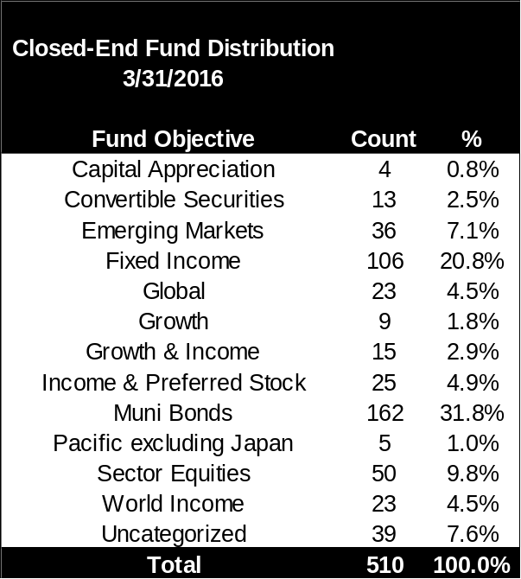
Based on calculations by Highland Global

The following table illustrates the descriptive statistics for each group of fund objectives.

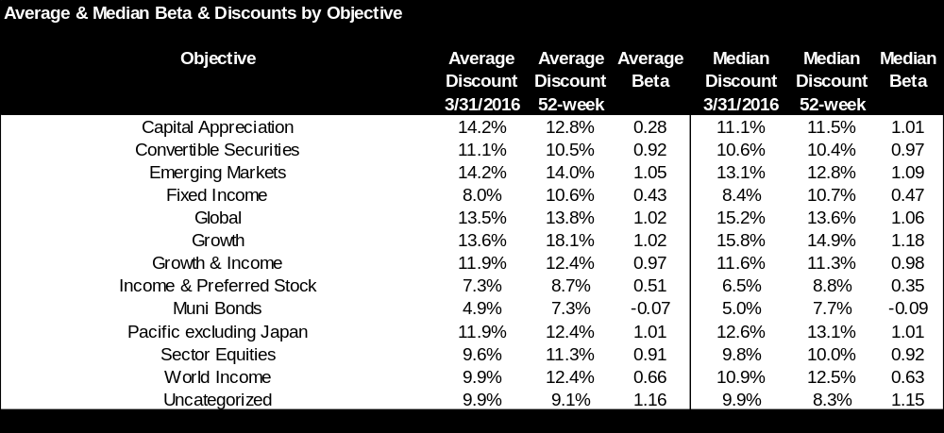
Based on calculations by Highland Global from data obtained from www.barrons.com and www.google.com/finance

The descriptive statistics presented in the previous tables may be useful in helping the analyst determine an appropriate baseline discount from which adjustments may be made to determine the final discount applicable to the minority interest being valued. In the end, however, the analyst always must use reasoned and informed judgment in determining the appropriate baseline discount and the adjustment from that baseline to reflect the particular risk characteristics of the minority interest being valued.

Barron’s Closed-End Fund Data

